What’s the difference between a ‘Type 1’ hypervisor and a ‘Type 2’ hypervisor?

What’s a Hypervisor?

A ‘hypervisor’ is the essence of the cloud technology that we all enjoy today.  Nowadays there exist many stable and feature-rich hypervisors: RetHat KVM, VMware, Microsoft Hyper-V, Oracle VirtualBox and Xen to name the more popular ones.  But with so many hypervisors around all with competing features, what makes them different from one another?  One of the main differences between hypervisor platforms is their classification as a ‘Type 1’ or a ‘Type 2’ hypervisor.  So what’s the difference between a Type 1 and a Type 2 hypervisor you ask?

Type 1 Hypervisors

In short, a Type 1 hypervisor is a virtualization platform which is delivered as an integral part of an operating system.

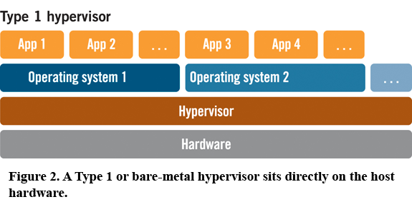

Type 2 Hypervisors

On the contrary, a Type 2 hypervisor is a virtualization platform which is delivered as a process that runs within an operating system.

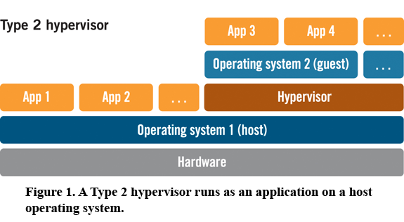

Based on this description, in theory a Type 1 hypervisor should outperform a Type 2 hypervisor as its path to the underlying hardware is shorter.  While varying opinions and findings on this topic can be found online Type 1 hypervisors usually win-out…  although that’s not always the case.

A List of Hypervisors and Their Types

For your interest, following is a listing the hypervisors mentioned above and their associated ‘type’:

* KVM: Type 2
* VMware ESXi: Type 1
* VMWare Player: Type 2
* Microsoft Hyper-V: Type 1
* Oracle VirtualBox: Type 2
* Xen: Type 1